APPLICATION FORM
INTERNATIONAL WEEK SWITZERLAND
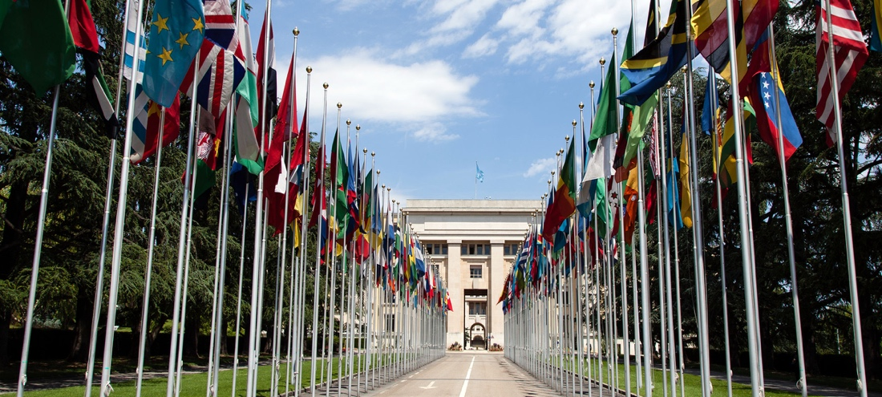
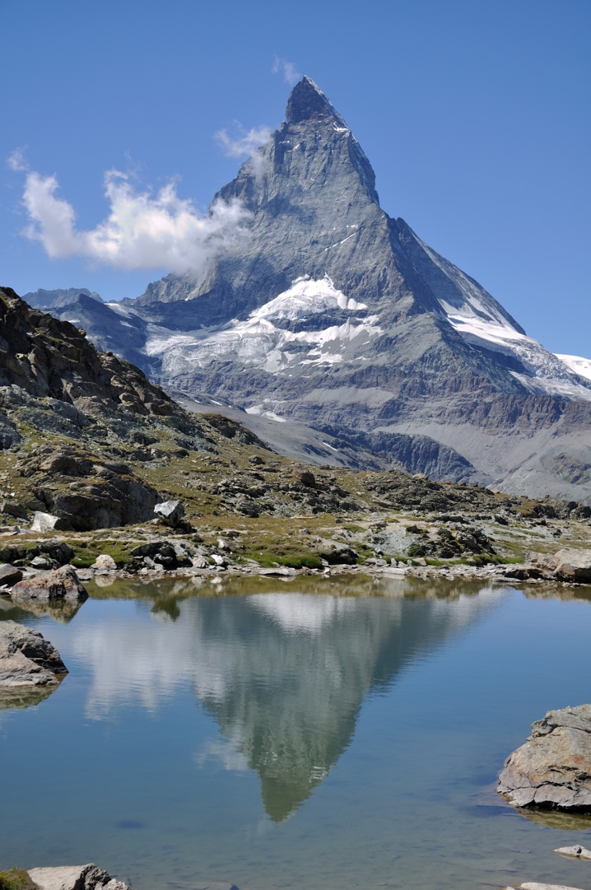
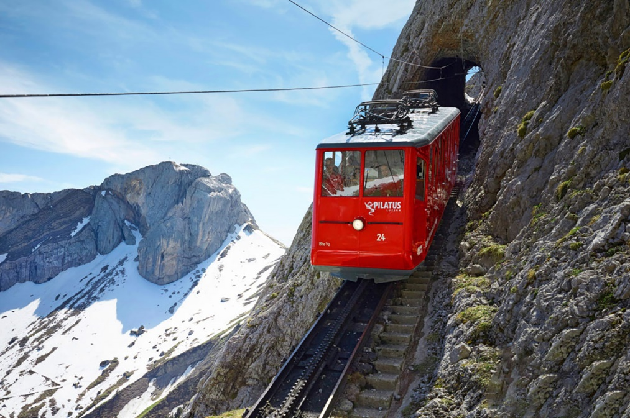
28TH MARCH – 5TH APRIL 2023
PERSONAL INFORMATION:
Full Name
Gender
Date of Birth: (dd/mm/yyyy)
Home Address
City/ Town
Zip Code
Country
Nationality
Passport/ Identification Number
Do you require a Visa?
E-mail Address
Your Instagram Account (if given)
Facebook URL
Your Phone Number (+Country Code)

EMERGENCY CONTACT INFORMATION:
Name of your Emergency Contact:
Your Relationship
Home Address
City/ Town
Zip Code
Country
Their Phone Number (+Country Code)
Their E-mail Address

INFORMATION ABOUT YOUR UNIVERSITY:
Name of University
City and Country
Your Field of Study
Your current Level of Study
Your Year of Study
Name of Home IW/Student Association
Name of Contact Person (from IW Committee)
E-mail Address of Contact Person (from IW Committee)

PERSONAL QUESTIONS:
Have you ever been to Switzerland?

Have you ever participated in or organized any IW? If yes, which one?

What do you expect from IW Switzerland?

What do you want to see in Switzerland?
Which languages do you speak? (Please also indicate your fluency)

INFORMATION FOR HOST MATCHING:
Do you prefer to be hosted by a …? | Boy ( ) Girl ( )
Do you smoke? | Yes ( ) No ( )
Do you mind staying with someone who smokes? | Yes ( ) No ( )
Do you mind if your host has a pet? | Yes ( ) No ( )
Do you mind sharing a room with the opposite gender? | Yes ( ) No ( )
Do you follow any special diet? | Yes ( ) No ( )
If yes, please specify

Do you have any allergies? | Yes ( ) No ( )
If yes, please specify

Are you currently under any medical treatment? | Yes ( ) No ( )
What do you usually eat for breakfast?

How many hours of sleep do you need?
Any comments for your host allocation

PERSONALITY QUESTIONS:
Please evaluate yourself on a scale 1 to 5

 | 1 | 2 | 3 | 4 | 5
Dependent |  |  |  |  |  | Independent
Night owl |  |  |  |  |  | Early bird
Talkative |  |  |  |  |  | Quiet
Spontaneous |  |  |  |  |  | Planned
Introvert |  |  |  |  |  | Extrovert
Picky eater |  |  |  |  |  | Un-picky eater
Party evening |  |  |  |  |  | Relaxed evening

WHO ARE YOU?
Please introduce yourself quickly in the text box below and tell us why you are the perfect participant for IW Switzerland and three unique/funny facts about you.

MOTIVATION VIDEO:
Please submit a video of you telling us about your favourite or craziest party story. If you have participated in an IW before, please tell us about your craziest IW experience! You can either attach your video in the e-mail or you can upload it on wetransfer and attach the link in the box below. The video should not be longer than 3 minutes. (Website to wetransfer: https://wetransfer.com/)

WE ARE LOOKING FORWARD TO MEETING YOU!
Important
Please send your application to the responsible person within our local IW Committee. Do not make any travel arrangements until you get our confirmation.

We are looking forward to receiving our applications!
IW Switzerland Committee

